Name

Practice Typing

What is your favorite color?



How old are you?

What is your animal?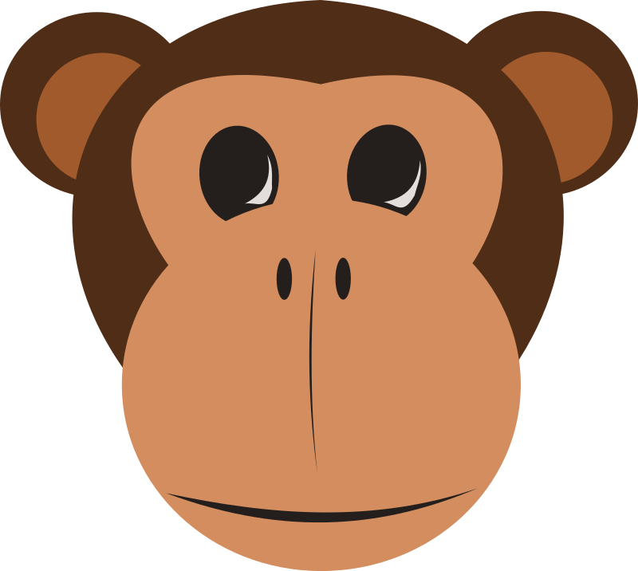

Favorite food

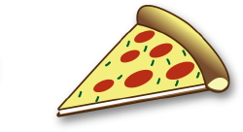

My name is

My name is